Version 2 The Maze Generator
In this version of our maze, we want to create a maze generator. A maze generator, is something that game makers can create, to automatically create their mazes for them. It takes the boredom out of the maze, and generates a new maze every time. So, each time the player returns, they are taken on a different journey.
Right now, we are using the wall tile map to surround our room. This is fine, but now we want to create a maze, that is generated in code. So, our game does not get confused with what it is supposed to be working with, we can separate the inner maze section to be represented by objects instead of tile maps. That way when we start to mess with rearranging different aspects of the maze, it doesn’t go in and start destroying the outer wall too.

Creating the Wall for the Maze
We will be using 3 different wall objects, to give the walls a bit of variety.
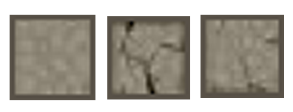

Create both a sprite and an object for each wall element.
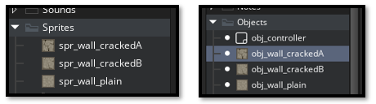
For the Sprite
Set up a canvas in Photo shop, size it to 64px X 64px.


- spr_wall_plain – sprite: solid wall
- spr_wall_crackedA -sprite cracked wall variation 1
- spr_wall_crackedB-sprite cracked wall variation 2
Warning: if your object want to come in a 32px, make sure you have recreated this wall sprite above at the 64px X 64px size. The object will be reading the size of the png.
For the Object
- obj_wall_plain – sprite: solid wall
- obj_wall_crackedA -sprite cracked wall variation 1
- obj_wall_crackedB-sprite cracked wall variation 2
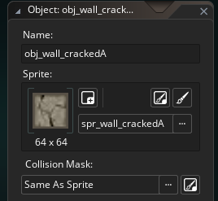
Make sure each has:
• Visible checked
• A collision mask (so the hero can’t walk through)
• Keep your outer boundary walls as a tilemap, untouched by the maze function.

Script Code
Create a new script code inside of the Script folder and name it carve_maze_objects.

function carve_maze_objects() {
var tile_size = 64;
var maze_w = room_width div tile_size;
var maze_h = room_height div tile_size;

// 🔮 The Grid Awakening
var maze_grid = array_create(maze_w, array_create(maze_h, false));
var maze_stack = [];
var my_x = 1;
var my_y = 1;
maze_grid[my_x][my_y] = true;
array_push(maze_stack, [my_x, my_y]);

// 🌀 The Corridor Carving (Recursive Backtracking)
while (array_length(maze_stack) > 0) {
var maze_current = maze_stack[array_length(maze_stack) - 1];
my_x = maze_current[0];
my_y = maze_current[1];

var maze_neighbors = [];
if (my_x > 2 && !maze_grid[my_x - 2][my_y]) array_push(maze_neighbors, [-2, 0]);
if (my_x + 2 < maze_w && !maze_grid[my_x + 2][my_y]) array_push(maze_neighbors, [2, 0]);
if (my_y > 2 && !maze_grid[my_x][my_y - 2]) array_push(maze_neighbors, [0, -2]);
if (my_y + 2 < maze_h && !maze_grid[my_x][my_y + 2]) array_push(maze_neighbors, [0, 2]);

if (array_length(maze_neighbors) > 0) {
var dir = maze_neighbors[irandom(array_length(maze_neighbors) - 1)];
var next_x = my_x + dir[0];
var next_y = my_y + dir[1];

// Carve corridor and intermediate wall
maze_grid[next_x][next_y] = true;
maze_grid[my_x + dir[0] div 2][my_y + dir[1] div 2] = true;

array_push(maze_stack, [next_x, next_y]);
} else {
array_pop(maze_stack);
}
}

// 🧱 The Wall Summoning Ritual (Safe Layer Check)
if (layer_exists("layer_maze")) {
for (var i = 0; i < maze_w; i++) {
for (var j = 0; j < maze_h; j++) {
if (!maze_grid[i][j]) {
var tile_x = i * tile_size;
var tile_y = j * tile_size;

// 🪄 Debug: show where walls are being spawned
show_debug_message("Wall at grid (" + string(i) + "," + string(j) +
") -> pixel (" + string(tile_x) + "," + string(tile_y) + ")");

// Weighted random choice of wall object
var r = irandom(99); // 0–99
if (r < 80) {
instance_create_layer(tile_x, tile_y, "layer_maze", obj_wall_plain);
} else if (r < 90) {
instance_create_layer(tile_x, tile_y, "layer_maze", obj_wall_crackedA);
} else {
instance_create_layer(tile_x, tile_y, "layer_maze", obj_wall_crackedB);
}
}
}
}

} else {
show_debug_message("⚠️ Layer 'layer_maze' does not exist. Maze walls not spawned.");
}}

The Controller Object
In the obj_controller, in the room start event, write this code.

Add the carve_maze_objects, call to the obj_controller.
// obj_controller: Room Start Event
room_initialize();
carve_maze_objects();
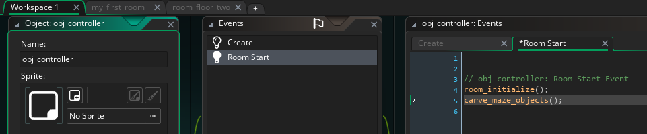

Adding a couple of New Layers
We want to create a couple of more layers in the game. One is going to be the Wall_Tiles_2 level, and the other one will be ‘layer_maze’
The Wall_Tiles_2 is a tile level.
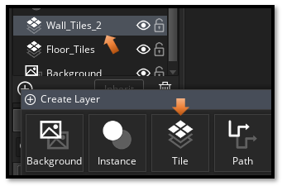
Change the Wall_Tile layer name.
Make sure you are in the second room.
Change the name of the wall_tile layer, so we can distinquished between them in the code.
The layer_maze is an instance layer.
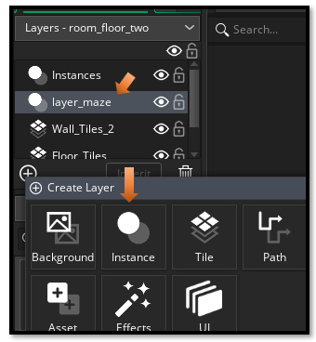

The Hero Object Code
// Movement input
var move_x = keyboard_check(vk_right) - keyboard_check(vk_left);
var move_y = keyboard_check(vk_down) - keyboard_check(vk_up);

var spd = 4;
var dx = move_x * spd;
var dy = move_y * spd;

// --- Attempt full diagonal move first ---
if (global.room_ready) {
if (dx != 0 || dy != 0) {

// 🌀 Floor 2: object-based maze walls
if (room == room_floor_two) {
// Check collision against maze wall objects (use parent if you set one)
if (!place_meeting(x+dx, y+dy, obj_wall_plain) &&
!place_meeting(x+dx, y+dy, obj_wall_crackedA) &&
!place_meeting(x+dx, y+dy, obj_wall_crackedB)) {
x += dx;
y += dy;
} else {
// Try horizontal only
if (!place_meeting(x+dx, y, obj_wall_plain) &&
!place_meeting(x+dx, y, obj_wall_crackedA) &&
!place_meeting(x+dx, y, obj_wall_crackedB)) {
x += dx;
}
// Try vertical only
if (!place_meeting(x, y+dy, obj_wall_plain) &&
!place_meeting(x, y+dy, obj_wall_crackedA) &&
!place_meeting(x, y+dy, obj_wall_crackedB)) {
y += dy;
}
}

} else {
// 🧱 Floor 1: tilemap-based walls
var nx_left = bbox_left + dx;
var nx_right = bbox_right + dx;
var ny_top = bbox_top + dy;
var ny_bottom = bbox_bottom+ dy;

var hit_diag =
wall_is_solid(nx_left, ny_top) ||
wall_is_solid(nx_right, ny_top) ||
wall_is_solid(nx_left, ny_bottom) ||
wall_is_solid(nx_right, ny_bottom);

if (!hit_diag) {
x += dx;
y += dy;
} else {
var hit_x =
wall_is_solid(bbox_left+dx, bbox_top) ||
wall_is_solid(bbox_right+dx, bbox_top) ||
wall_is_solid(bbox_left+dx, bbox_bottom) ||
wall_is_solid(bbox_right+dx, bbox_bottom);

if (!hit_x) {
x += dx;
}

var hit_y =
wall_is_solid(bbox_left, bbox_top+dy) ||
wall_is_solid(bbox_right, bbox_top+dy) ||
wall_is_solid(bbox_left, bbox_bottom+dy) ||
wall_is_solid(bbox_right, bbox_bottom+dy);

if (!hit_y) {
y += dy;
}
}
}
}
}

// --- Sprite switching ---
if (move_y < 0) sprite_index = sprite_hero_back;
else if (move_x > 0) sprite_index = sprite_hero_right;
else if (move_x < 0) sprite_index = sprite_hero_left;
else sprite_index = sprite_hero;

